Workshop Web Server
(TIF330805)

LAPORAN



ACARA 6

WIDYA ANITAR ROSYIDAH
NIM E41250352

TEKNIK INFORMATIKA KAB. NGANJUK
JURUSAN TEKNOLOGI INFORMASI
POLITEKNIK NEGERI JEMBER
TAHUN 2026

ACARA 6 Middleware, Auth Sederhana, dan Struktur Folder Lengkap
Studi Kasus
Halaman dashboard, form tambah mahasiswa, dan halaman edit hanya boleh diakses user yang sudah login. Tanpa proteksi, siapa pun yang tahu URL bisa masuk. Middleware Auth mengecek session sebelum Controller dijalankan. Jika belum login, user diarahkan ke halaman login.
Tujuan
Mahasiswa menyusun struktur folder lengkap, membuat AuthController (login/logout), dan melindungi beberapa route dengan AuthMiddleware.
Langkah
- Susun folder sesuai struktur di atas.
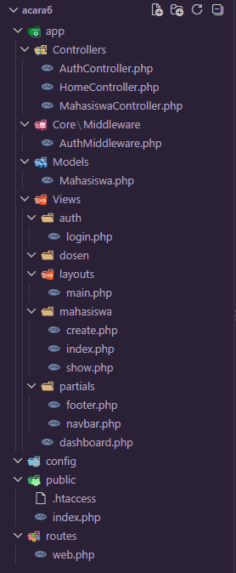
- Buat AuthController dengan method loginForm, login, logout.
<?php

namespace App\Controllers;

class AuthController
{
public function loginForm(): void
{
if (!empty($_SESSION['logged_in'])) {
header('Location: ' . BASE_URL . '/dashboard');
exit;
}

$title = 'Login | SI Akademik';
$content = __DIR__ . '/../Views/auth/login.php';
require __DIR__ . '/../Views/layouts/main.php';
}

public function login(): void
{
$username = trim($_POST['username'] ?? '');
$password = $_POST['password'] ?? '';

if ($username === 'admin' && $password === 'admin123') {
session_regenerate_id(true);
$_SESSION['user_id'] = 1;
$_SESSION['user_name'] = 'Admin';
$_SESSION['logged_in'] = true;
$_SESSION['flash'] = 'Selamat datang, Admin';

header('Location: ' . BASE_URL . '/dashboard');
exit;
}

http_response_code(422);
$error = 'Username atau password salah.';
$title = 'Login | SI Akademik';
$content = __DIR__ . '/../Views/auth/login.php';
require __DIR__ . '/../Views/layouts/main.php';
}

public function logout(): void
{
$_SESSION = [];
session_destroy();
session_start();
$_SESSION['flash'] = 'Anda telah logout';

header('Location: ' . BASE_URL . '/login');
exit;
}
}

- Buat form login sederhana.
<div class="row justify-content-center">
<div class="col-md-6 col-lg-5">
<h1 class="h3 mb-4">Login</h1>
<?php if (!empty($error)): ?>
<div class="alert alert-danger" role="alert">
<?= htmlspecialchars($error, ENT_QUOTES, 'UTF-8') ?>
</div>
<?php endif; ?>
<form method="POST" action="<?= BASE_URL ?>/login" class="bg-white border rounded p-4">
<div class="mb-3">
<label for="username" class="form-label">Username</label>
<input type="text" class="form-control" id="username" name="username" required autocomplete="username" value="<?= htmlspecialchars($_POST['username'] ?? '', ENT_QUOTES, 'UTF-8') ?>">
</div>
<div class="mb-3">
<label for="password" class="form-label">Password</label>
<input type="password" class="form-control" id="password" name="password" required autocomplete="current-password">
</div>
<button type="submit" class="btn btn-primary">Masuk</button>
</form>
</div>
</div>
- Simulasikan login sukses dengan hardcode username/password dulu (nanti diganti database).
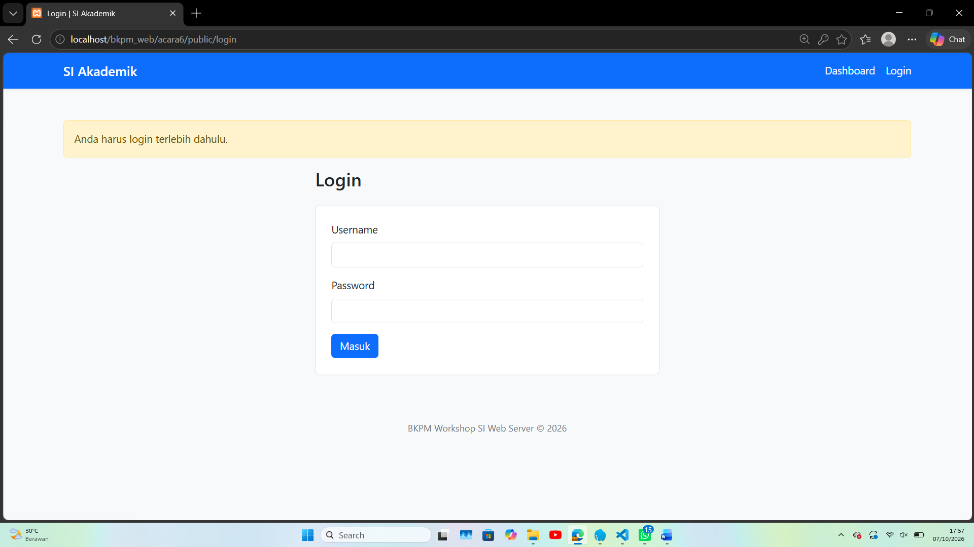
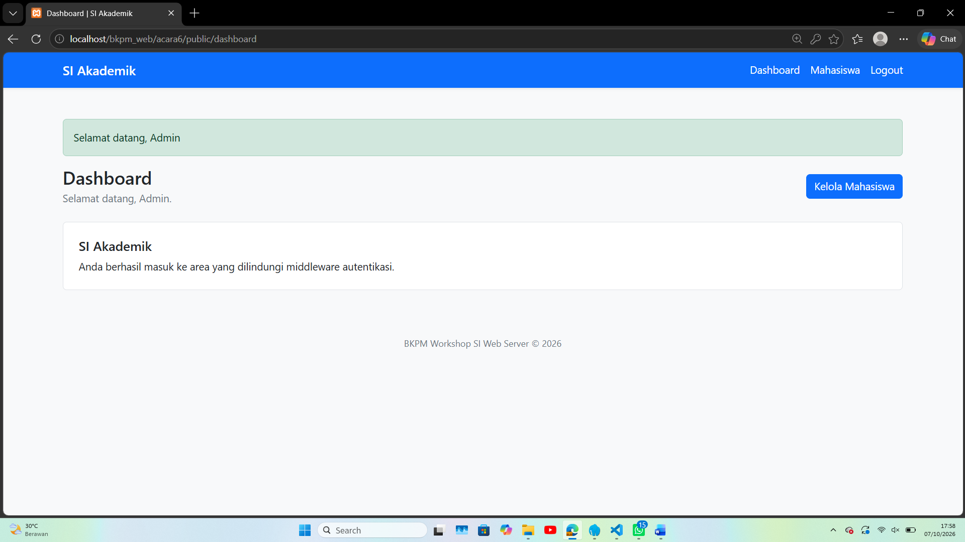
- Pasang AuthMiddleware pada route /dashboard dan /mahasiswa.
<?php

namespace App\Controllers;

class AuthController
{
public function loginForm(): void
{
if (!empty($_SESSION['logged_in'])) {
header('Location: ' . BASE_URL . '/dashboard');
exit;
}

$title = 'Login | SI Akademik';
$content = __DIR__ . '/../Views/auth/login.php';
require __DIR__ . '/../Views/layouts/main.php';
}

public function login(): void
{
$username = trim($_POST['username'] ?? '');
$password = $_POST['password'] ?? '';

if ($username === 'admin' && $password === 'admin123') {
session_regenerate_id(true);
$_SESSION['user_id'] = 1;
$_SESSION['user_name'] = 'Admin';
$_SESSION['logged_in'] = true;
$_SESSION['flash'] = 'Selamat datang, Admin';

header('Location: ' . BASE_URL . '/dashboard');
exit;
}

http_response_code(422);
$error = 'Username atau password salah.';
$title = 'Login | SI Akademik';
$content = __DIR__ . '/../Views/auth/login.php';
require __DIR__ . '/../Views/layouts/main.php';
}

public function logout(): void
{
$_SESSION = [];
session_destroy();
session_start();
$_SESSION['flash'] = 'Anda telah logout';

header('Location: ' . BASE_URL . '/login');
exit;
}
}

- Uji: akses /mahasiswa tanpa login harus redirect ke /login.
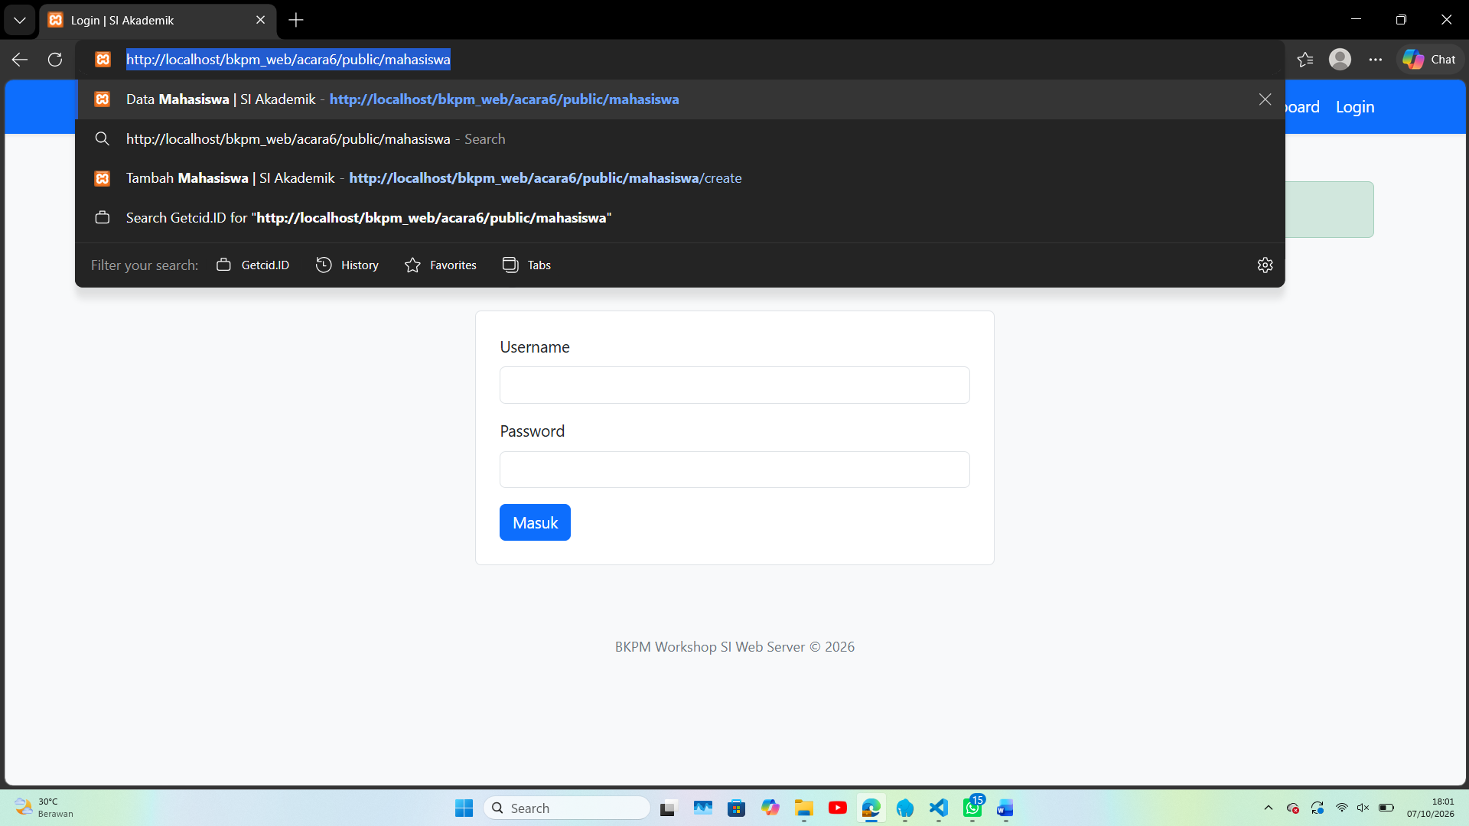
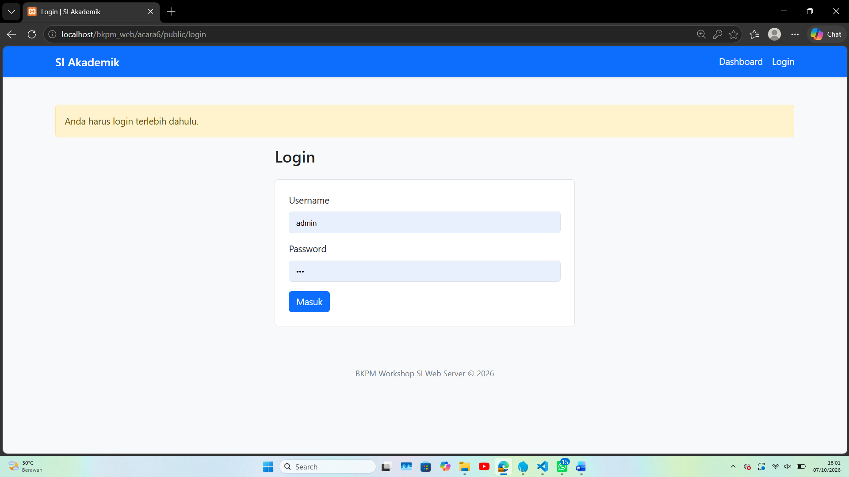
Tugas Mandiri
Tambahkan flash message: setelah login sukses, tampilkan alert "Selamat datang, Admin" di dashboard. Setelah logout, tampilkan "Anda telah logout".

